

**MERU UNIVERSITY OF SCIENCE AND TECHNOLOGY**

**BACHELOR OF SCIENCE IN COMPUTER TECHNOLOGY**

**DEPARTMENT OF COMPUTER SCIENCE**

**FINAL YEAR PROJECT**

**LOCATION-BASED GARBAGE MANAGEMENT SYSTEM**

**Presented by:**

**NEWTON OMONDI OSAGE CT202/100798/19**

**A project submitted in fulfillment of the requirements of the Bachelor of Science in Computer Technology Meru University of Science and Technology**

**April,2022**

**Supervised by:**

**DR. MARY W. MWADULO**

**DECLARATION**

The content of this document is the original work based on my own research and to the best of my knowledge, it has not been presented elsewhere for academic purposes.

NEWTON OMONDI OSAGE Signed…………………………

This project is submitted as part of the Examiners Board requirement for the award of the degree of Bachelor of computer technology from the Meru University of Science and Technology.

Project supervisor:

#### DR. MWADULO

Signed ………………………… Date: ……………………………….

Table of Contents

**CHAPTER ONE** 1

**INTRODUCTION** 1

**1.1** **Background of study** 1

**1.2** **Motivation for study** 1

**1.3** **Problem statement** 2

**1.3.1** **General objectives** 2

**1.3.2** **Specific objectives** 3

**1.4** **Significance of the study** 3

**1.5** **Scope of the study** 3

**1.6** **Limitations of study** 4

**CHAPTER TWO** 5

**LITERATURE REVIEW** 5

**2.2.1 Request making** 5

**2.2.2 Trash Pick** 6

**2.2.3 Dumping** 6

**2.2.4 Registration** 6

**2.2.5 Log in** 6

**2.3.1 Effectiveness** 7

**2.3.2** 7

**2.3.3 Impact** 7

**2.5.1 Use of Unsuitable Vehicles** 8

**2.5.2 Lack of Public Co-operation** 8

**2.5.3 Littering and Illegal Dumping** 8

**CHAPTER THREE** 12

**METHODOLOGY** 12

**3.0 Overview** 12

**3.1 Sample research Design** 12

**3.2 Population, Sample and Sampling** 12

**3.3 Data Collection, Instrumentation and Procedure** 13

**3.5 System Development Methodology** 14

**3.6 Data Processing and Analysis** 15

**3.7 Ethical Considerations** 16

**3.8 Summary** 17

**CHAPTER FOUR** 18

**SYSTEM ANALYSIS** 18

**4.3.1 Functional Requirements** 22

**4.3.2 Non-functional Requirements** 22

**4.3.2.1 Authentication** 23

**4.3.2.2 Availability** 23

**4.3.2.3 Portability** 23

**4.3.2.4 Security** 23

**4.3.2.5 Accessibility** 23

**CHAPTER FIVE** 25

**SYSTEM DESIGN** 25

**5.0 Overview** 25

5.1 Logical design of the location based garbage management system. 25

**5.2 Physical design** 27

**5.2.1 Welcome Page** 27

**5.2.2 Registration Form** 28

**5.2.3 User dashboard** 28

**5.2.4 Assign Garbage Bin** 29

**5.2.5 Admin dashboard** 30

**5.3 Database design of the new location-based garbage management system.** 30

**5.3.1 Admin table** 30

**5.3.2 Garbage bin table** 31

**5.3.3 Tracking table** 31

**5.3.3 Drivers table** 32

**5.3.4 Complain table** 32

**5.4 Summary** 33

**CHAPTER SIX** 34

**SYSTEM IMPLEMENTATION** 34

**6.0 Overview** 34

**6.1 Implemented Features location-based garbage management system** 34

6.1.1. Geolocation Feature 34

**6.1.2 Report generation feature** 35

6.1.3 Complain and feedback feature 36

**6.1.4 Payment feature** 37

**6.2 System Testing** 38

6.2.2 Bin location 39

**6.2.3 Notification feature** 39

**6.3 System Changeover** 40

**6.3.1 System changeover** 40

**6.3.2 Parallel changeover** 40

**6.3.3 Direct changeover** 40

**6.3.4 Pilot changeover** 40

**6.3.5 Phased changeover** 40

**6.4 Documentation** 41

**6.5 Summary** 42

**CHAPTER SEVEN** 43

**7.0 Findings** 43

**7.1 Conclusion** 43

**7.2 Recommendation/ future work** 44

**REFERENCES** 46

**Appendices** 49

Appendix A 49

Appendix B 50

**Questionnaire** 50

APPENDIX C**: RESEARCH SCHEDULE** 53

**APPENDIX D: BUDGET** 55

**APPENDIX E** 56

**USER MANUAL: LOCATION-BASED GARBAGE MANAGEMENT SYSTEM** 58

# **CHAPTER ONE**

# **INTRODUCTION**

# **Background of study**

Waste management is a pressing issue in urban areas, with increasing urbanization leading to the generation of large amounts of waste. Traditional waste management systems often face challenges such as inefficient collection and disposal methods, lack of proper monitoring, and inadequate resource utilization (Monika K A, 2015). To address these challenges, innovative solutions such as the Location-Based Garbage Management System have emerged, utilizing modern technologies such as Internet of Things (IoT), Geographic Information Systems (GIS), and data analytics to optimize waste management processes.  
A crucial component of the Location-Based Garbage Management System is a web-based application that provides an interactive and user-friendly interface for managing various aspects of waste management (Parkash, Prabu 2019). This application can be accessed through web browsers on desktop or mobile devices, enabling stakeholders such as waste drivers, city officials, and residents to interact with the system in real-time.

# **Motivation for study**

In cities of rapid urbanization, such as Nairobi, Kenya, there are a ton of flats and apartments that have been erected due to population increase. Due to the need for most residents to make ends meet, there has been a migration from rural to urban areas. The residents of the apartments deal with a number of challenges. One of them is the problem of how to dispose of household solid waste without causing pollution. In contrast to landed homes, garbage disposal bins in flats are shared by everyone who lives in the same building, which causes the bins to fill up quickly.

Moreover, there are issues with each apartment's resident's attitudes. There have been instances where some careless inhabitants, who often reside on the upper levels of the building, have littered or have simply thrown their household waste into the trash cans while on the floor where they reside. The main issues that are now encountered with effective waste management and disposal may without a doubt be resolved by implementing environmental conservation and management systems.

## **Problem statement**

The current garbage collection management involves manual payment collection, residents seeking out garbage collectors, and disposal in potentially illegal landfills, resulting in pollution and environmental degradation. There is a need for an innovative solution that utilizes modern technologies such as IoT and GIS through a web-based application to optimize waste management processes. The proposed Location-Based Garbage Management System aims to address these challenges by providing an interactive and user-friendly interface for managing various aspects of waste management, collecting and storing data on a database, and utilizing location-based information to efficiently route garbage trucks.

**Research objectives**

The objective of this research is to establish the current trends, opportunity and challenges in the management of e-garbage in Kenya. Moreover, the research also intends to study the landscape and make recommendations on measures to be taken to effectively manage or mitigate the effects of e-garbage proliferation in Kenya. The main goal of the research is to enlighten policy makers and government agencies on the steps that need to be taken to effectively manage garbage in environmentally sound ways and seize the available opportunities.   
The study informs policy and guide implementers on possible mechanisms of enforcement. The academia, civil society, donors and sponsors of e-waste management projects will also benefit from the knowledge generated.

### **General objectives**

The objective of this project is to develop a location-based garbage management system for Meru residential apartments.

### **Specific objectives**

1. To enable the system to assign garbage bins to users.
2. To enable the system to provide route planning for the collection based on the selected fill level and priorities of each bin.
3. To enable the system to generate a response to the complaints issued by the users
4. To enable the system to generate a weekly report on the collected garbage bins.
5. To enable the users to track the status of the complaints issued.

## **Significance of the study**

The problem of e-waste management is a global issue and with the dire need for industrial growth in Kenya brought about by the vision 2030 and constitution that embraces county government and industrial growth, the problem of e-waste is likely to grow to unmanageable levels if the problem is not addressed. The study will therefore address the problem of e-waste in manufacturing and processing industries hence ensuring functional systems and structures are put in place to ensure proper e-waste management hence reducing significantly the human and environmental effects that are brought about by the industry mismanagement. The study will also seek to define roles of different stakeholders on matters concerning e-waste management hence closing the gaps that have been left on e waste management cycle; the study will also seek to review with purpose to strengthen various institutional frameworks concerned with waste management and specially e-waste.

## **Scope of the study**

The proposed system will focus on maintenance of sanity in the environment and preventing pollution that might result in severe health complications to the inhabitants of the areas where garbage and environment conservation is not put into consideration.

## **Limitations of study**

Inaccessibility: most of the residential areas in industrial area are slums hence making access difficult, some of the industries cannot be accessed by public transport as they are located far from the cities.

Sensitivity of the topic of study: the topic of study was sensitive to some of the people I interviewed and therefore they could not willingly disclose all the information they have.  
 Inadequate technical information: many of the respondents have no technical information on e-waste and therefore I could not obtain quality information as anticipated. In other areas I was denied entry into their premises, making it difficult for me to conduct interviews in those companies.

# **CHAPTER TWO**

# **LITERATURE REVIEW**

**2.0 Overview**

The records that follow demonstrate that there is no centralized system for garbage pickup, transportation, and management. The studies further claim that there is no overall strategy to solve the issue.

**2.1 Functionalities of the existing location-based garbage management system**

**Smart waste management** focuses on solving the previously mentioned solid waste management problems using sensors, intelligent monitoring systems, and mobile applications. The first smart waste management solution to make the waste collection process more efficient is sensors. Sensors can measure the fill level of the containers and provide updated information at any time and notify waste management services to empty them when they are full or almost full. These devices help optimize the best possible route containing fully filled containers and create smart schedules for drivers. The selection of the containers also minimizes the need for trash collection staff because their duties are deduced. They can also alert the waste management companies or municipalities if an undesirable incident happens such as sudden temperature rise or displacement of the container by their GPS features .

**2.2 Components of existing location-based garbage management system**

### **2.2.1 Request making**

This interface is mainly for the user to request the system to pick the garbage of their house; they give the details of their home offer to pick the trash at a particular time according to their wish of time. As he confirms the request to select, the application data will go to the managers, and further, the managers will take care of it to pick the garbage from the house.

### **2.2.2 Trash Pick**

The manager takes the request and comes to the place with their vehicles which are already registered in the system. They come and weigh the garbage, or they can set the estimation and tell the price and loads the garbage move to the dumping yard.

### **2.2.3 Dumping**

There might be more than one dumping yard that why the dimensions and capacity should be known to the manager to dump the garbage as sometimes accurately, it is full and nowhere no space left to drop. The calculation of the area and source destination and distance is calculated to minimize the cost of travel.

### **2.2.4 Registration**

Users’ information has to be compelled to be registered within the system thus on establish every one of them unambiguously and do the required group action as real potential. Like on the name of the bill are issued. On the far side, this plenty of things require measure wherever the user is referenced. Without registration, there are few options and pages one user can see which are landing on the home page and tasking the features to read but he will not be allowed to use. For use, he will have to register. One person needs to put all the details correctly and precisely as it will be helpful in identifying them and believing that he is the real person who has booked for the same.

### **2.2.5 Log in**

After registration one will register within the system because of the operator of the system either on behalf of the user. When this he has the different helpful interfaces accessible for any actions. Here either bride or groom both have to log in with their unique identity and passwords. After this, they are directed to the primary user interface from where they have further options.

**2.3 Features of existing location-based garbage management system**

**2.3.1 Effectiveness**

Majority of the waste collection vehicles owned by Konza city authorities were replaced with new vehicles and new waste disposal equipment was introduced. This upgrading enhanced the waste collection rate. Also, the enforcement of the project led to practice in disposal activities, such as the removal and compression of waste. Moreover, in order to prevent a breakdown of the supplied equipment, the systems for periodical equipment inspection and parts management in the Managua authorities were established. Therefore, it can be concluded that the goal of this project has been accomplished.

**2.3.2** **Efficiency**

The operation rate of the provided facilities was high, since the technical level necessary for operation of the equipment supplied was adequate and the Nicaraguan staff was selected properly. It is believed that the efficiency in the input of Japan's side was high.

### **2.3.3 Impact**

The enforcement of the project improved the collection and disposal of waste, resulting in a decrease of bad odor and diseases, and in an improvement in the cityscape. Also, the introduction of new facilities created new employment opportunities in the Managua city authorities for the operation and maintenance of new facilities.

**2.4 Types of existing location-based garbage management system   
2.4.1 Smart solid waste management** **systems**

A big challenge in the urban cities is solid waste management not only in Kenya but for most of the countries in the world. Hence, such a system has to be built which can eradicate this problem or at least reduce it to the minimum level. The project gives us one of the most efficient ways to keep our environment clean and green.

**2.4.2 Manual garbage management system**

This system involves picking up of garbages from the filled areas for disposal , recycling or reuse. Some waste materials may be reclaimed or re-generated and used again for their original or similar purpose, or they may be physically or chemically changed and employed for alternative uses. As natural resources continue to be depleted, and as incineration and landfill disposal options become more costly and unsustainable, numerous economic and social incentives are being promoted by government agencies to prevent or reduce waste generation and develop new methods and technologies for [recycling](https://courses.lumenlearning.com/suny-sustainability-a-comprehensive-foundation/chapter/systems-of-waste-management/#id1170467320356) and reusing wastes.

**2.4.3 location-based garbage management system**

The proposed system overview for this system. Solid waste management can be broadly categorized as segregation, collection, and transportation. Based on the data collected, garbage trucks can be given routes generated through various algorithms and google maps API to efficiently route through all necessary garbage bins and finally reach the dumping site.

**2.5 Challenges of existing location-based garbage management system**

### **2.5.1 Use of Unsuitable Vehicles**

In selecting vehicles for waste collection two errors are commonly made. One of them is to choose advanced compactor trucks when they are not suited to the local conditions.

### **2.5.2 Lack of Public Co-operation**

[Solid waste collection](https://evreka.co/blog/solid-waste-let-the-garbage-do-the-job/) is a service that requires the co-operation and participation of a large proportion of the citizens. If street bins are inconvenient to use, people may drop their waste beside a container rather than in it.

### **2.5.3 Littering and Illegal Dumping**

There are many reasons why citizens drop or scatter waste in streets, watercourses, and open areas. It is known that improved practice and public education campaigns have a positive impact. However, it is useful also to consider why wastes are not put in the designated containers and how wastes come to be dispersed in public places.

**2.6 Related studies**

1. "Optimizing Waste Collection Routes using Location-Based Services" by Hensher, D. A., & Button, K. (2008): This study discusses the use of location-based services in optimizing waste collection routes, considering factors such as travel time, distance, and capacity utilization to improve efficiency.
2. "Design and Implementation of an Intelligent Garbage Collection System based on Internet of Things (IoT)" by Ali, F., Hussain, I., & Anwar, A. (2018): This study presents the design and implementation of an IoT-based garbage collection system that uses location-based information for efficient garbage collection.
3. "Smart Garbage Monitoring System using Internet of Things (IoT)" by Shahid, N., Hussain, M., & Hussain, M. (2017): This study proposes a smart garbage monitoring system using IoT technologies, including location-based services, for real-time monitoring of garbage bins and optimizing collection routes.
4. "Optimization of Solid Waste Collection Routes using GIS-based Spatial Analysis: A Case Study of Bogotá, Colombia" by Arrieta, E. M., & Moreno, A. T. (2016): This study presents a case study of optimizing solid waste collection routes using GIS-based spatial analysis, including location-based data, to improve the efficiency of garbage collection in Bogotá, Colombia.
5. "Location-Based Waste Collection Management System: A Case Study for Cypriot Municipalities" by Karakikes, I., & Themistocleous, M. (2019): This study presents a location-based waste collection management system using GIS and GPS technologies for Cypriot municipalities, highlighting the benefits of optimized routing and resource allocation.
6. "A Review of Location-Based Services for Waste Collection in Smart Cities" by Caviglione, L., García, D., & Lera, I. (2017): This study provides a comprehensive review of location-based services for waste collection in smart cities, discussing various approaches, technologies, and challenges in implementing such systems.
7. "Design and Development of a Real-time Location-Based Garbage Collection System for Smart Cities" by Reddy, P. N., & Ravi, C. (2017): This study presents the design and development of a real-time location-based garbage collection system for smart cities, incorporating GPS and GIS technologies for optimizing waste collection routes.
8. "Optimization of Waste Collection Routes for Smart Cities: A Comparative Analysis of Metaheuristic Algorithms" by Gupta, S., & Jain, S. (2018): This study compares and analyzes different metaheuristic algorithms for optimizing waste collection routes in smart cities, considering location-based data and other constraints.
9. "Location-Based Waste Collection Routing Optimization for Smart Cities: A Comparative Study" by Chen, J., & Chen, Z. (2019): This study compares different routing optimization techniques for waste collection in smart cities, including location-based data, to evaluate their efficiency and effectiveness.
10. "Optimization of Municipal Solid Waste Collection Route using Geographical Information System: A Case Study in Pune City" by Kulkarni, A., & Kanetkar, P. (2018): This study presents a case study of optimizing municipal solid waste collection routes using GIS-based spatial analysis, considering location-based information, to improve the efficiency of waste collection in Pune City, India.
11. "Smart Waste Management System using Big Data Analytics: A Location-Based Approach" by Pingle, S. S., & Yadav, A. (2019): This study proposes a smart waste management system using big data analytics, including location-based data, for optimizing waste collection routes and improving resource allocation in urban areas.
12. "Development of a Smart Garbage Collection System using Internet of Things and Predictive Analytics" by Chowdhury, M. M. R., & Chowdhury, M. E. (2018): This study presents the development of a smart garbage collection system using IoT and predictive analytics, including location-based information, for real-time monitoring and optimization of waste collection routes.
13. "An Intelligent Waste Collection System for Smart Cities using Machine Learning and IoT Technologies" by Hossain, M. A., & Hasan, R. (2019): This study proposes an intelligent waste collection system for smart cities using machine learning and IoT technologies, including location-based data, for optimizing waste collection routes and improving resource allocation.
14. "Real-Time Route Optimization for Garbage Collection: A Case Study in Dhaka City" by Islam, S. S., & Ahmed, S. U. (2019): This study presents a case study of real-time route optimization for garbage collection in Dhaka City, Bangladesh, using location-based data and optimization algorithms to improve the efficiency of waste collection.
15. "Smart Waste Collection System for Smart Cities using LoRaWAN and GIS Technologies" by Roy, P., & Sarkar, S. (2018): This study proposes a smart waste collection system for smart cities using LoRaWAN and GIS technologies, including location-based data, for optimizing waste collection routes and improving resource allocation.

**2.7 Summary**

The developed system provides an improved database for garbage pickup time and therefore the quantity of garbage pickup at each location. By implementing this project, overflowing garbage from the container in residential areas could be solved, which was previously either loaded manually or with the assistance of loaders within the traditional trucks.   
All necessary hardware and software are available for implementing the project. The project is ideal for saving time and changing the regular way of dumping trash. Keep the world neat and clean and supply the residents with a waste-free environment.

# **CHAPTER THREE**

# **METHODOLOGY**

# **3.0 Overview**

The records that followed demonstrated that there was no centralized system for garbage pickup, transportation, and management. The studies further claimed that there was no overall strategy to solve the issue.

# **3.1 Sample research Design**

The research design was an arrangement of settings for data collecting and analysis that sought to balance relevance to the study goal with procedural economy. It described how to collect data, measure it, and analyze the same data. This study used a descriptive research design, which was defined as a research method that described the characteristics of the population that was being studied. A diagnostic research project was one in which the researcher sought to identify the root cause of a problem. He elucidated the circumstances that had led to the current predicament.

Finally, the research design could be experimental, which was how this study was conducted. In natural research, an experimental design was used, but in social science, it was not. Human behavior could not be studied in test tubes or under a microscope. Experimental research was the most familiar type of research design for individuals in the physical sciences and a host of other fields. This was mainly because experimental research was a classical scientific experiment, similar to those performed in high school science classes. The research design was appropriate for developing the online student e-voting system because it helped ensure that the methods matched the research aim. It also helped in collecting high-quality data and coming up with the right analysis to answer the project questions. And this allowed us to draw some valid, trustworthy conclusions.

# **3.2 Population, Sample and Sampling**

A research population was also known as a well-defined collection of individuals or objects known to have similar characteristics. All individuals or objects within a certain population usually had a common, binding characteristic or trait. While a target population was the entire group of individuals or objects to which researchers were interested in generalizing the conclusions. The target population usually had varying characteristics and was also known as the theoretical population. Another type of population was the accessible population, defined as the population in research to which the researchers could apply their conclusions. It was from the accessible population that researchers drew their samples. The target population in this research comprised all 100 households. The choice of the target population was based on the fact that it was convenient for the researcher to gather data.

Sampling was the process of selecting a subset of individuals within a population to estimate characteristics of the whole population. It could also be defined as the act, process, or technique of selecting a representative part of a population for the purpose of determining parameters of the whole population.

There were different forms of sampling, including random sampling, systematic sampling, clustered sampling, and stratified sampling. Random sampling was the sampling method that allowed for the randomization of sample selection, where each sample had the same probability as the other sample to be selected to serve as a representation of the entire population. Systematic sampling was a type of probability sampling method where a researcher chose elements from a target population by selecting at random with a fixed starting point. Clustered sampling involved dividing the population into smaller groups called clusters, and then a random selection was done from the clusters. Stratified sampling involved dividing the population into smaller groups called strata.

# **3.3 Data Collection, Instrumentation and Procedure**

According to (M.D.Pawar,2018) data collection was the procedure of collecting, measuring, and analyzing accurate insights for research using standard validated techniques. There were several data collection tools that could be used in research. This included:

**Questionnaire**

According to (M.D.Pawar,2018) a questionnaire is a list of questions or items used to gather data from respondents about their attitudes, experiences, or opinions. Questionnaires can be used to collect quantitative and/or qualitative information. Questionnaires can include close-ended, open-ended, short-form and long-form questions.

**Interviews (structured, phone, group)**

According to (M.D.Pawar,2018) , interviews are used to collect data from a small group of subjects on a broad range of topics. You can use structured or unstructured interviews. Structured interviews are comparable to a questionnaire, with the same questions in the same order for each subject and with multiple choice answers.

**Observation**

According to (M.D.Pawar,2018), observation is a way of gathering data by watching behaviour, events, or noting physical characteristics in their natural setting. Observations can be overt (everyone knows they are being observed) or covert (no one knows they are being observed and the observer is concealed).

**Prototyping**

According to (M.D.Pawar,2018) , prototyping is a technique whereby single or multiple data sources are transformed into a resultant dataset without any operational systems being impacted.

**JAD**

According to (M.D.Pawar,2018), is a process that accelerates the design of information technology solutions. JAD uses customer involvement and group dynamics to accurately depict the user's view of the business need and to jointly develop a solution.

This study will use questionnaire to collect data. Questionnaire is the most appropriate data collection tool for this research because it is economical, it offers a wide coverage, it is easy to use, it puts less pressure on the respondents, it ensures uniformity and avoids repetitive information. We will use questionnaire to collect data from both students and lecturers to get both responses from the participants and the organizers.

Two separate semi-structured questionnaires (one for lecturers and one for students) containing closed and open-ended items will be distributed by the researcher to the participants who in turn will fill in the questionnaire at convenient times due to their busy schedules. This will give respondents the opportunity to freely express their views on paper by either ticking the appropriate boxes and/or filling in the blank spaces provided for on the questionnaire. A follow-up to collect the completed questionnaires will be done within an interval of one week making it possible to achieve a questionnaire return rate of about 70% for both the lecturers and the students.

**3.4 Development tools and material**

This study will use the following components:

Hardware Requirements 1 GB RAM, 200 GB HDD, Intel 1.66 GHz Processor Pentium4. Software Requirements include Visual Studio Code, Windows Operating System. Visual Studio Code is a source-code editor that can be used with a variety of programming languages,including [Java](https://en.wikipedia.org/wiki/Java_(programming_language)), [JavaScript](https://en.wikipedia.org/wiki/JavaScript), [Go](https://en.wikipedia.org/wiki/Go_(programming_language)), [Node.js](https://en.wikipedia.org/wiki/Node.js), [Python](https://en.wikipedia.org/wiki/Python_(programming_language)), [C++](https://en.wikipedia.org/wiki/C%2B%2B), [C](https://en.wikipedia.org/wiki/C_(programming_language)), [Rust](https://en.wikipedia.org/wiki/Rust_(programming_language)) and [Fortran](https://en.wikipedia.org/wiki/Fortran) platform that provides the services necessary for developers to build an applications. For the database where employees details will be stored us will use MySQL, wampp will then be used to deploy admin web app and web API.

# **3.5 System Development Methodology**

Systems development methodology (SDM) is a standard process followed in an organization to conduct all the steps necessary to analyze, design, implement and maintain information systems (IS). It is highly beneficial for organizations to adopt a systems development methodology to develop IS.

System Development Methodology includes: Waterfall model is a breakdown of project activities into linear sequential phases, where each phase depends on the deliverables of the previous one and corresponds to a specialization of tasks.

Spiral Development Model involves a risk-driven [software development process](https://en.wikipedia.org/wiki/Software_development_process) model that involves a combination of iterative development process model and sequential linear development model.

Agile Software Development Model is a group of software development methodologies based on iterative development, where requirements and solutions evolve through collaboration between self-organizing cross-functional teams.

(Prof K.K.Kokate,March 20-21, 2018) Defined RAD (Rapid Application Development**)** as a model based on prototyping and iterative development with no specific planning involved. The process of writing the software itself involves the planning required for developing the product.

In this study, the focus was on Rapid Application Development (RAD) as it consisted of the following phases:

i. Planning Phase: This involved gathering the system requirements and conducting a quick analysis. In this phase, all the necessary tools and materials were gathered, and a plan for the entire process was created.

ii. Prototyping Phase: In this phase, designs and models for the prototype were created, and development followed thereafter.

iii. Testing Phase: This phase involved validating the models and conducting unit testing and registration.

iv. Cutover Phase: This was the final phase that included data conversion and deployment of the system. The development of a prototype was the first step, and analysis was continuous throughout the process.

# **3.6 Data Processing and Analysis**

Data processing in research is the collection and translation of a data set into valuable, usable information. Data processing starts with data in its raw form and converts it into a more readable format (graphs, documents, etc.) giving it the form and context necessary to be interpreted by computers and utilized by employees throughout an organization (Prof K.K.Kokate,March 20-21, 2018). It involves data cleaning and editing of data.

According to (Wilson, D. C,2007) Data Analysis is a process of inspecting, cleaning, transforming and modeling data with the goal of discovering useful information, suggesting conclusions and supporting decision-making.

The data analysis process helps in reducing a large chunk of data into smaller fragments, which makes sense. There are two statistical measures that a researcher can use to analyze data i.e. descriptive and inferential.

Descriptive analysis according to (Kim Peters,2018) is the type of analysis of data that helps describe, show or summarize data points in a constructive way such that patterns might emerge that fulfill every condition of the data. Descriptive statistics, data from the entire population or a sample is summarized with numerical descriptors such as: Mean, Standard Deviation for Continuous Data and Frequency, Percentage for Categorical Data (Kim Peters,2018)

Inferential statistic uses patterns in the sample data to draw inferences about the represented population or accounting for randomness. These inferences can be answering yes/no questions about the data (hypothesis testing) estimating numerical characteristics of the data (estimation) describing associations within the data (correlation) and modeling relationships within the data example regression analysis (Agarwal,2016).

This research will incorporate both descriptive and inferential statistics, since descriptive statistics will use the data to provide descriptions of the population, either through numerical calculations or graphs or tables or charts. While, inferential statistics will help make inferences and predictions about a population based on a sample of data taken from the population in general.

# **3.7 Ethical Considerations**

Ethical considerations in research are a set of principles that guide your research designs and practices. These principles include voluntary participation, informed consent, anonymity, confidentiality, potential for harm, and results communication (Prabu,2019) The main goals of ethical consideration are to protect the rights of research participants, enhance research validity and maintain scientific integrity.The study of Online Garbage Collection System will be subjected to ethical standards: where everyone will have the freedom to participate and contribute ideas with no judgment.

# **3.8 Summary**

In the chapter a detailed discussion has been given on the components of the research design where the researchers chose the experimental form of research design and an elaboration on the same, population sample and the sampling technique to be used has been explained. Data collection and procedures, development tools and materials where the hardware and software requirements to be used are highlighted. System development methodology, data processing and analysis and an ethical consideration is given.

# **CHAPTER FOUR**

# **SYSTEM ANALYSIS**

**4.0 Overview**

The location based garbage management system system is web application

**4.1 Feasibility study**

A short assessment of the current location based garbage management system was carried out to determine whether developing a new system is a viable solution. An analysis on the worthiness to commit the resources to developing a location based garbage management system was carried out.  
To do these a feasibility study was conducted. A feasibility study is merely an evaluation of how realistic a project plan or procedure is. ( Monika K A,2015) By examining technical, economic, legal, operational, and time feasibility factors, this is accomplished. How useful the new system will be to the organization can be measured with the help of feasibility.  
Although the institution technically has enough computers to execute the planned system, it will be necessary to upgrade the RAM and software for all the machines, which was discovered during the feasibility assessment.  
The ability of the system to match the capacity planning, resources, strategic goals, and commercial objectives that this system has fulfilled is referred to as operational feasibility( Harish Kumar, 2020). Time feasibility is well utilized in this current system by timely projection of the deadline met to develop the system (Harish Kumar, 2016).

**4.2 Overall Description of the location based garbage management system**The Location-Based Garbage Management System for Smart City app combines the most basic testing methods with data analysis to offer the most basic answer to keep the area clean and monitor driver performance. ( Monika K A,2015) Residents have access to an internet program that effectively makes it easier for them to discard rubbish and waste. People can file a complaint to keep their neighborhood tidy and clean as well as hold the driver responsible for the situation.

**4.2.1 location based garbage management system Use-case diagram**Use cases are a way for locating, outlining, and organizing system needs in system analysis. The use case consists of a number of potential interactions between users and systems in a specific environment that are connected to a specific objective. The procedure generates a document that lists each step a user took to finish an activity.

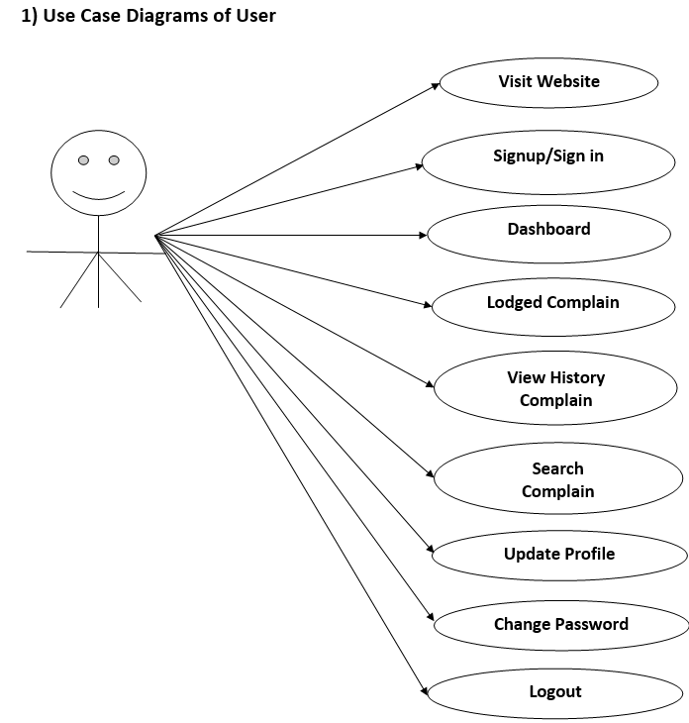

figure 4 :

***Figure 4.1 Use-case diagram***

**4.2.2 location based garbage management system activity diagram**

Activity diagrams show how multiple levels of abstraction of activities are coordinated to produce a service. ( Prof Dr.V.V.Todkar, 2021)Typically, an event must be accomplished by some operations, especially when the operation is meant to accomplish several different things that call for coordination. Another common requirement is how the events in a single use case relate to one another, especially in use cases where activities may overlap and require coordination.

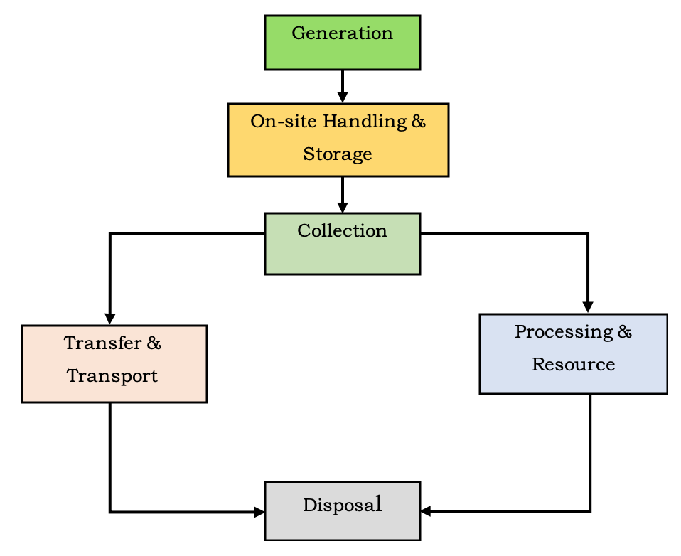

***Figure 4.2: Activity diagram***

**4.2.2 location based garbage management system Data-flow diagram**

A data flow diagram (DFD) shows how information moves through any system or process. It displays data inputs, outputs, storage locations, and routes between each destination using predefined symbols such rectangles, circles, and arrows as well as brief text labels.( Prof Dr.V.V.Todkar, 2021)

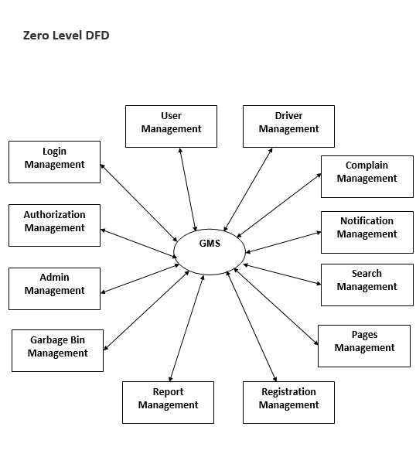

***Figure 4.3: data-flow diagram***

**4.3 Requirement Gathering**

It’s the practice of researching the requirements of any system from users, employees and other stakeholders (Wilson, D. C, 2007). These requirements are either functional or non-functional.

# **4.3.1 Functional Requirements**

It defines the function of a system where a function is described based on specifications of behavior between inputs and outputs (A. Jayakody, 2017).

**4.3.1.1 Register**A website or program may have this icon where a new user can sign up(Wilson, D. C, 2007). The system administrator is then given a platform to create user accounts by entering their information, which includes username, password, email address, phone number, identification number, and user image.

**4.3.1.2 Create/update bin**Administrator can create a garbage bin for different areas. Which is used for wasted collections from the areas then trucks can contain the garbage bin.( Kim Peters,2017)

He is also responsible to update new bin or any bin that is not used.

**4.3.1.3 Manage driver**Admin manages all the drivers and maintains the best bin drivers.( Kim Peters,2017)

**4.3.1.4 Generate report**Administrator is able to generate report of dustbins that are frequently filled up(Prapulla,2015)

**4.3.1.5 Assign best route**The driver is given the shortest route to beat certain drawbacks such as traffic and smell all over.

# **4.3.2 Non-functional Requirements**

This is a requirement that defines the criteria that can be used to judge operations of a system rather than its behaviors (City farmer,2015).

## 

## **4.3.2.1 Authentication**

It’s the act of proving an assertion such as the identity of a computer system (Kim Peters,2017). Authentication involves offering users with credentials like username and unique passwords every time they need to access the system. This details are stored in the database for future comparisons.

## **4.3.2.2 Availability**

It refers to the ability of the users to obtain services or access the system whether to request for approval or to check if the leave is approved (Kim Peters,2017).The location based garbage Management System is available to its users at any hours both working and non-working hours. Availability is measured using the number of access and mean time repair.

## **4.3.2.3 Portability**

It’s the usability of the software in different environments (Reddy,2016). The location based garbage Management System can be used both on smartphones and laptops. The system can be installed and used at any convenient place and time, Portability is measured through the cost to adopt the software to new environments.

## **4.3.2.4 Security**

Its protection from resilience against potential harm caused by others by restraining the freedom of others to act (A. Bhargava, 2016). The location based garbage Management System adopts the use of passwords to ensure only authorized personals have access. The system is also protected from copyright issues.

## **4.3.2.5 Accessibility**

It is a general term used to explain the degree to which a product, project or system is accessible by as many people as possible (A. Bhargava,2016)

**4.4 Summary**

The developed system provides an improved database for garbage pickup time and therefore the quantity of garbage pickup at each location. By implementing this project, we'll avoid overflowing garbage from the container in residential areas which was previously either loaded manually or with the assistance of loaders within the traditional trucks. All necessary hardware and software are available for implementing the project. The project is ideal for saving time and changing the regular way of dumping trash. Keep the world neat and clean and supply the residents with a waste-free environment.(S.Mary, 2018)

# **CHAPTER FIVE**

# **SYSTEM DESIGN**

# **5.0 Overview**

In this chapter is about the main design of the new system through the ER diagram. It also discusses about the physical and database design of the new online car reservation system.

## 5.1 Logical design of the location based garbage management system.

According to (Biscobing, 2021) an ER Diagram also known as an entity relationship model, is a graphical representation that depicts relationships among people, objects, places, concepts or events within an information technology (IT) system.

Entity relationship diagrams provide a visual starting point for database design that can also be used to help determine information system requirements throughout an organization.

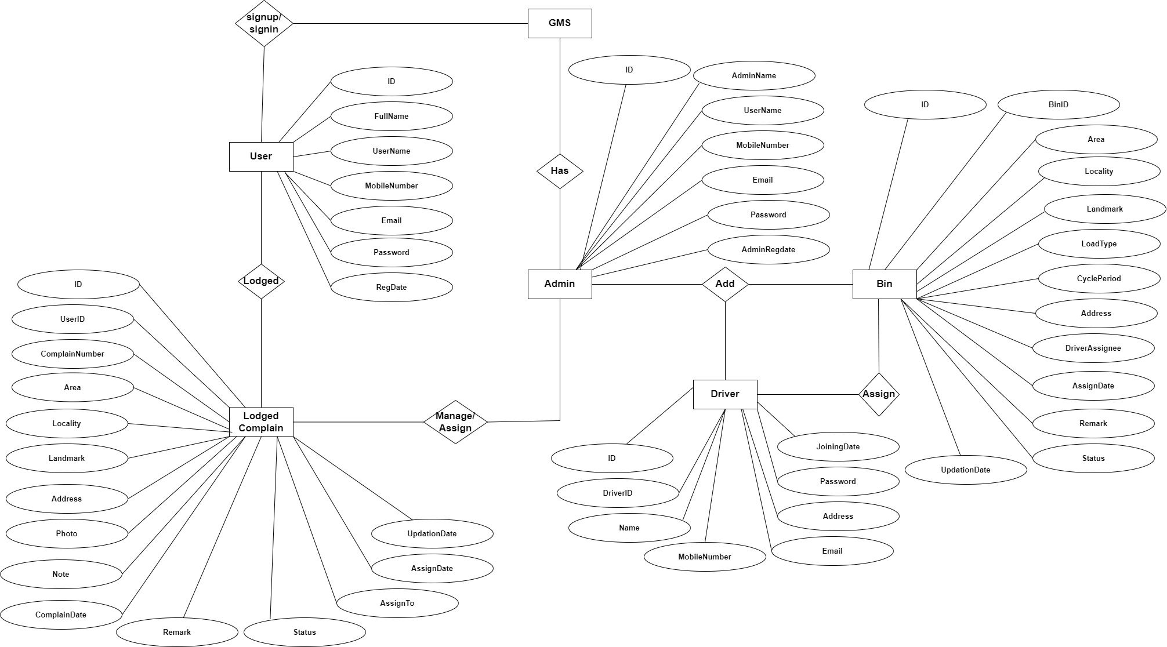

Figure 5.1: ER diagram for location based garbage management system

# **5.2 Physical design**

## **5.2.1 Welcome Page**

When users (drivers, administrators, and residential users) choose to use this website, this page is displayed. They can read about the system's operation while on this page or register so they can use the platform's services.

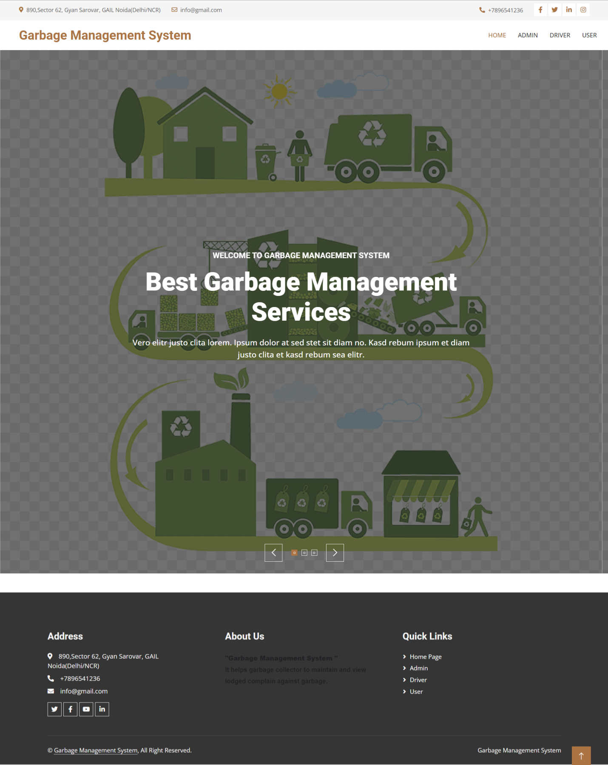

Figure 5.0 Welcome page

## **5.2.2 Registration Form**

Only users have access to this form. Drivers simply login using the credentials given to them after being registered by the admin.

First, the user must register. The user must click the register link on the home page's right side in order to access this page. Before adding the record, the user must fill out the mandatory fields (user email, mobile number and password).

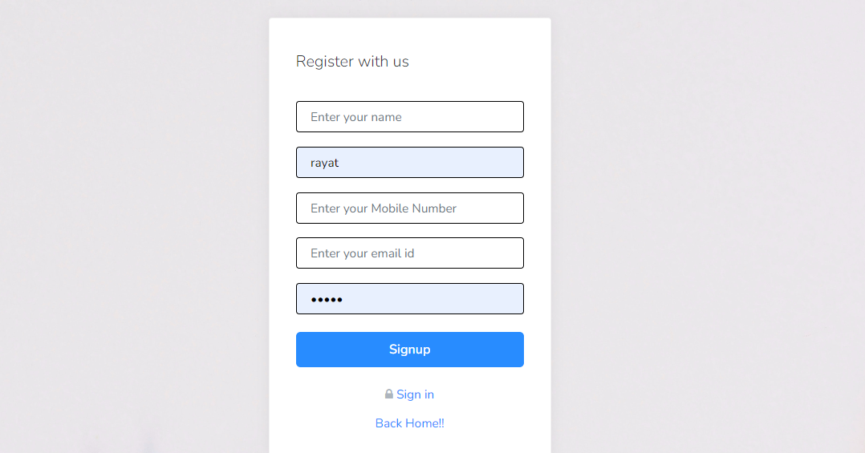

Figure 5.1 Showing user Registration Form

## **5.2.3 User dashboard**

By selecting the log in link from the home page, you can access this interface. Residential users can pay for the dumpsters, examine the dustbins nearby, and lastly submit complaints on this portal.

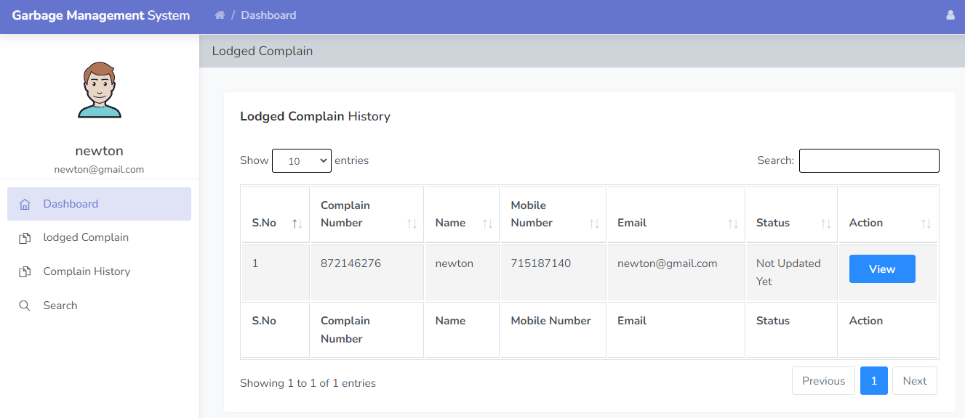

Figure 5.2 User dashboard

## **5.2.4 Assign Garbage Bin**

In this section, driver can view the assign garbage bin which is given by admin and also have right to change the status of work.

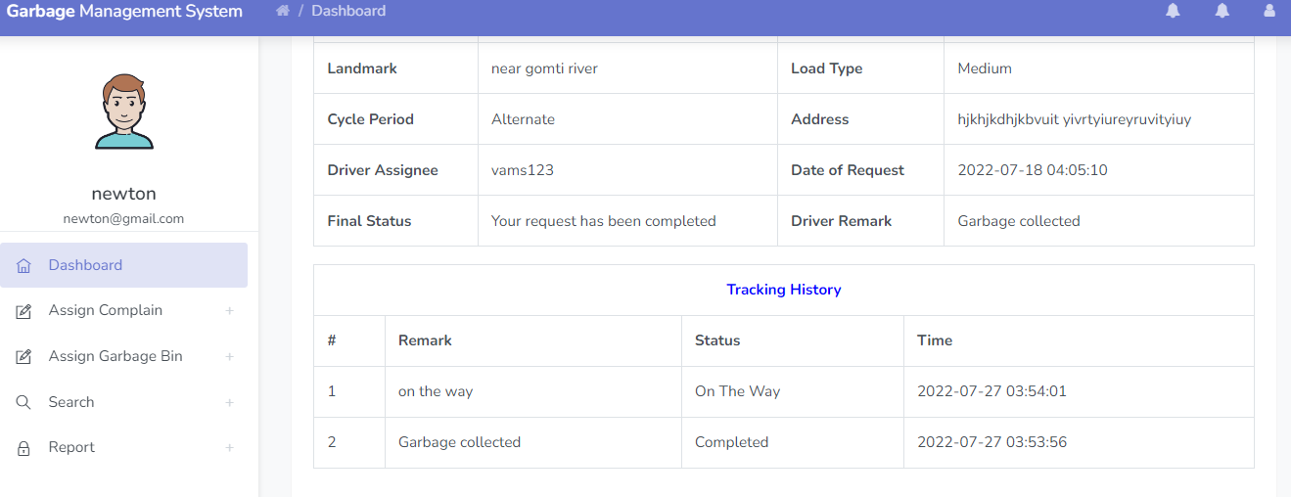

Figure 5.4 showing garbage bin

## **5.2.5 Admin dashboard**

In this section, admin can view all the detail in brief like new lodged complaints, Assigned lodged complaints, Rejected lodged complaints, Completed lodged complaints, total drivers ,total bin cleaning in progress and total bin cleaned.

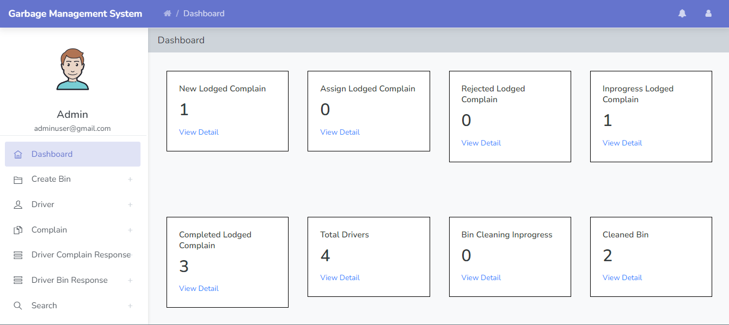

Figure 5.5 admin dashboard.

# **5.3 Database design of the new location-based garbage management system.**

## **5.3.1 Admin table**

This table store the login details of admin.

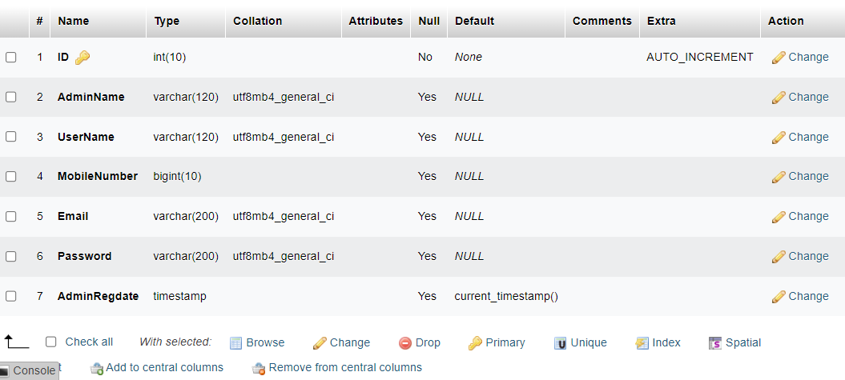Table 5.1: Admin table

## **5.3.2 Garbage bin table**

This table store the garbage bin details.

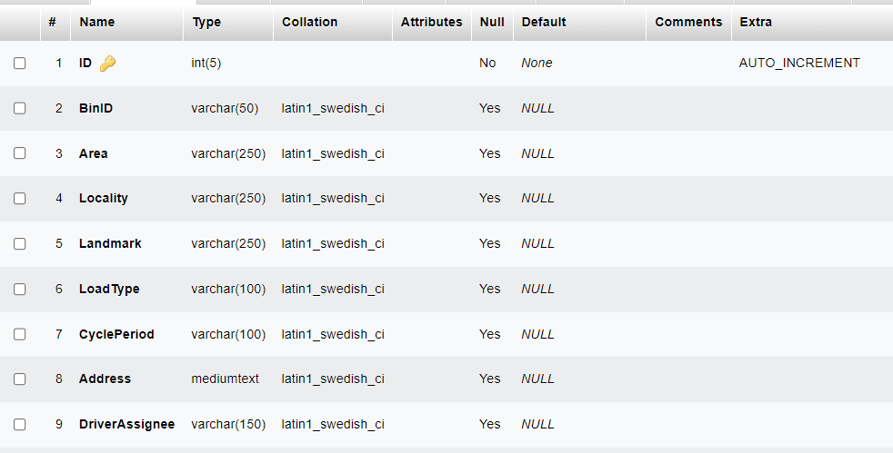

Table 5.2: garbage bin table

## **5.3.3 Tracking table**

This table store the tracking details of lodged complain which is mark by admin and driver.

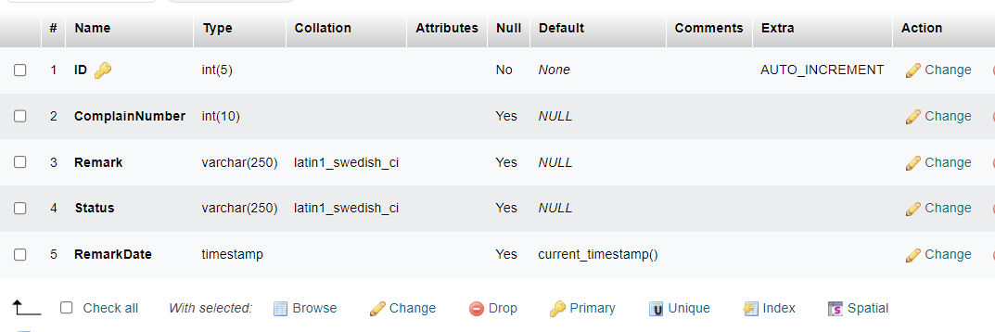

Table 5.3: tasks table

## **5.3.3 Drivers table**

The drivers table includes the id (primary key).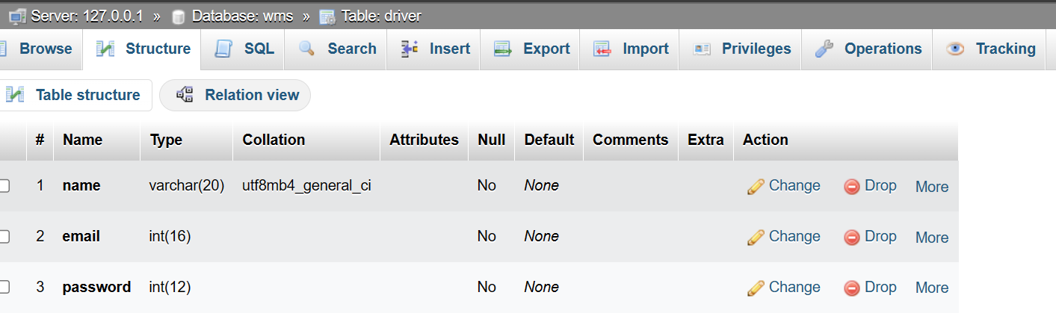

Table 5.4: drivers table.

## **5.3.4 Complain table**

This table store the details of lodged complain which is filed by users.

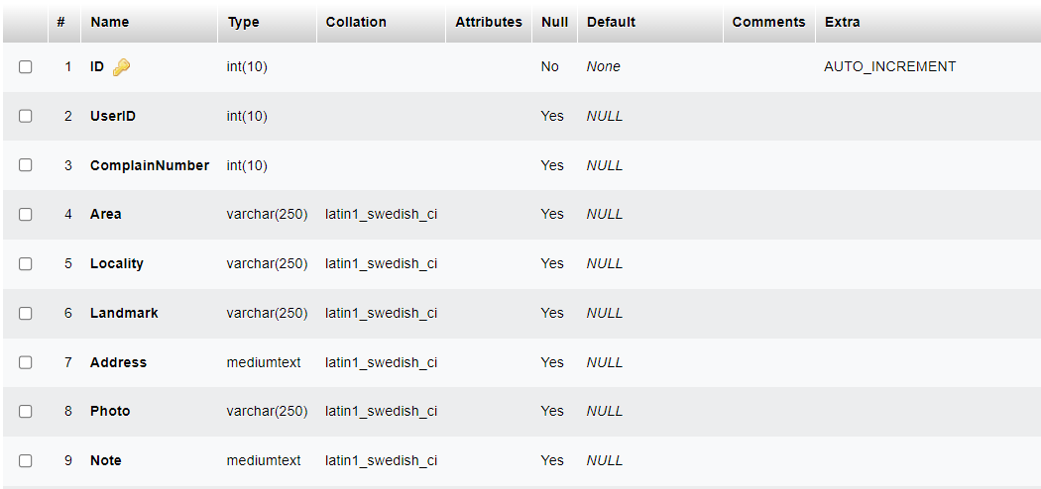

# **5.4 Summary**

The user application allows users to register their location and request a garbage pickup. The garbage collector application allows garbage collectors to view the garbage pickup requests and navigate to the location of the garbage bins. The administration dashboard allows administrators to monitor the system and view reports on the system's performance.

# **CHAPTER SIX**

# **SYSTEM IMPLEMENTATION**

**6.0 Overview**The implementation of the location-based garbage management system involves the actual development and deployment of the software system. In this chapter, we discuss the implementation features including the registration, geolocation, report generation and payment features. The chapter also contains screenshots of their codes which contribute to the working of the system.

# **6.1 Implemented Features location-based garbage management system**

6.1.1. Geolocation FeatureGeolocation is a feature in a location-based garbage management system that uses GPS (Global Positioning System) or other location technologies to track the location of garbage bins or dumpsters in real-time. The system collects data on the location of garbage bins, their fill levels, and other relevant information, which can be used to optimize the waste collection process.

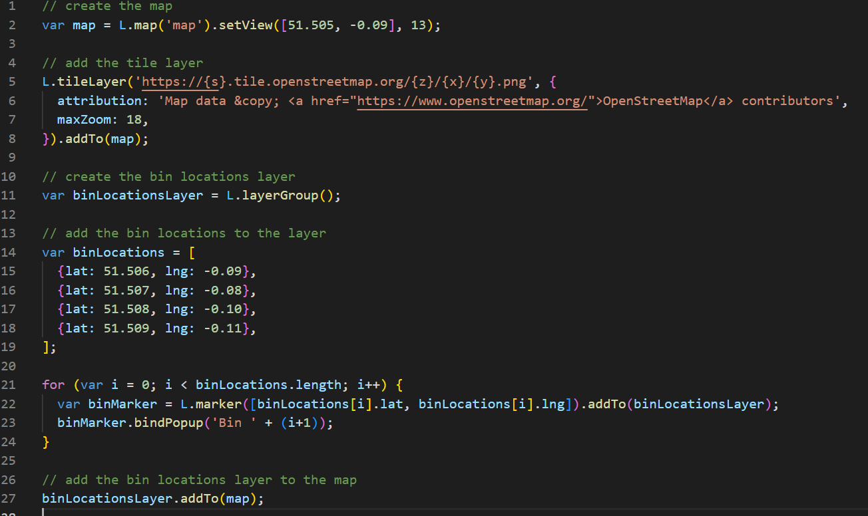Figure 6.1: code syntax of the geolocation feature.

**6.1.2 Report generation feature**  
The report generation feature allows the system to determine the monthly report on the fill-level of the bins. This feature requires collecting, processing, and analyzing data and deploying it to the web application.

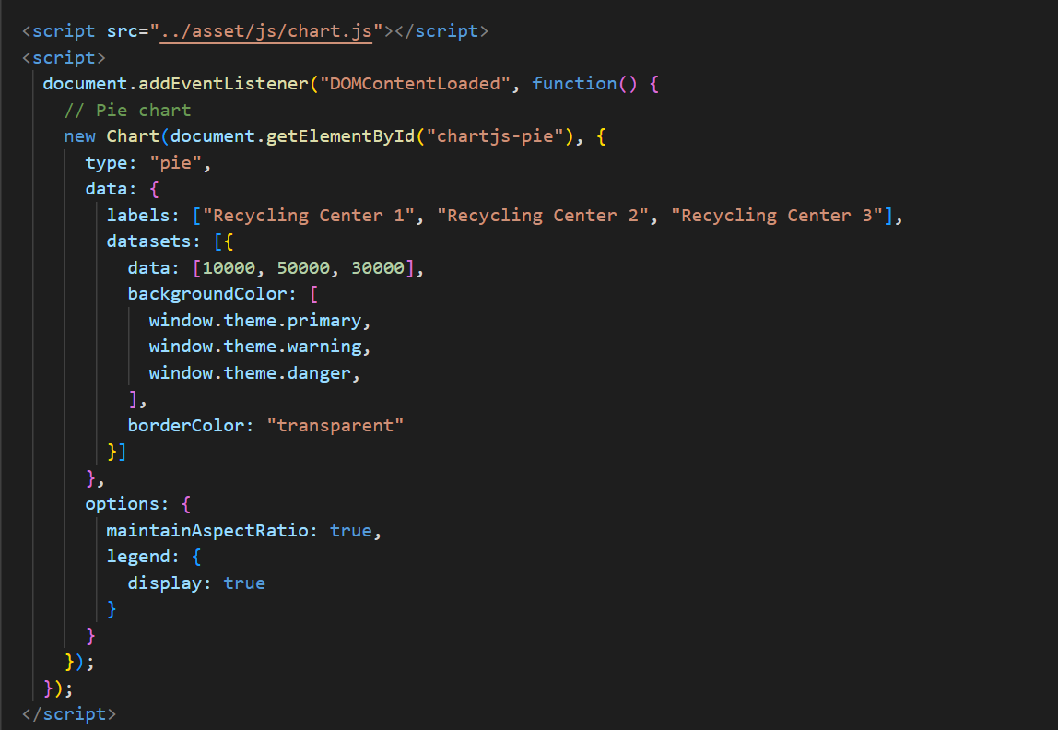

Figure 6.2: code syntax for the report generation feature.

6.1.3 Complain and feedback featureThis feature allows users to register complains with their email and the intended message. The admin upon receiving the information, responds and the user is notified.

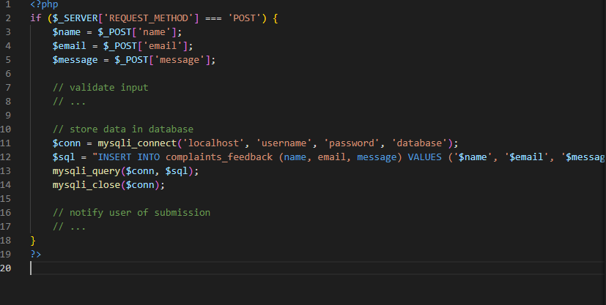

Figure 6.3: code syntax for the complaint feature.

**6.1.4 Payment feature**This payment feature allows users to make payments for services provided by the system. Each household allocated a dustbin to be paid through an integrated payment gateway with their web application, so users can make payments seamlessly.

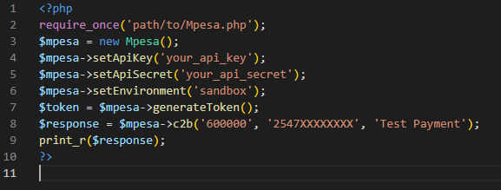

Figure 6.4: code syntax for the mpesa feature.

# **6.2 System Testing**

According to (Beizer,1995), "System testing is the process of testing an integrated system to verify that it meets specified requirements. System testing is conducted to evaluate the compliance of a system or component with specified functional requirements and non-functional requirements such as reliability, performance, and usability."  
Testing a location-based garbage management system involves field testing to ensure that the system works correctly in real-world scenarios, preparing test data to simulate real world garbage collection scenarios, and analyzing testing results to evaluate the system's performance. The following aspects of the system were focused on during the testing of the system;  
**6.2.1 Registration feature**  
The system should allow a user, driver and admin to register into the system by using a valid email and password. The feature was tested on the ability of the module to function as expected and data validation. Table 6.1 shows the test results

|  |  |  |  |
| --- | --- | --- | --- |
| **Test data** | | **Test type** | **Test Result** |
| **Email** | **Password** |
| newto@gmail.com | ****** | Test validity of the email which should be a mixture of numbers and characters | Pass |
| Ghost.123 | • | Test the strength of the password, it should not be less than 8 characters must contain at least a special character and a number | Pass |

## 6.2.2 Bin location

The system should allow a user to view the dustbin for their area online. This feature was tested on the ability to allow input into the form, submit the input data, validate the input data and store the data in the database. Table 6.2 show the results

Table 6.2: bin location

|  |  |  |  |
| --- | --- | --- | --- |
| **Test Field** | **Test data** | **Test Results** | |
| **Data validation** | **Data Storage into the database** |
| Username | Newton Nchiru [30,20] | Pass | Pass |
| Bin location | Nchiru | Pass | Pass |

## **6.2.3 Notification feature**

The system send notifications to garbage management authorities and collectors when garbage bins are full and in need of collection. This helps to optimize collection routes and ensure that garbage is collected in a timely manner. They are notified through email.

|  |  |  |
| --- | --- | --- |
| **Test data** | **Test type** | **Test results** |
| Email | Smtp mail function | pass |
| User email | Character email | pass |

Table 6.2.3: bin location

# **6.3 System Changeover**

System changeover refers to the process of transitioning from an old system to a new one. It involves a series of steps, including planning, testing, and implementation, to ensure a smooth transition without causing any disruptions to the business operations. According to (Bocij,2017), a successful system changeover requires careful planning, risk assessment, and effective communication with stakeholders to ensure that the new system meets the organization's needs and objectives.

**6.3.1 System changeover** refers to the process of transitioning from an existing information system to a new one. There are several types of system changeover, including parallel, direct, pilot, and phased changeover.

**6.3.2 Parallel changeover** involves running the old and new systems concurrently for a period of time. This approach enables users to compare the output from both systems and identify any discrepancies. It is a low-risk approach to changeover because if the new system fails, users can still fall back on the old system. However, it can be costly and time-consuming to maintain both systems simultaneously (Valacich, George, & Hoffer, 2017).

**6.3.3 Direct changeover** involves implementing the new system on a specific date and discontinuing the use of the old system immediately. This approach can be risky because if the new system fails, there is no backup. However, it is usually the fastest and cheapest approach to changeover (Valacich et al., 2017).

**6.3.4 Pilot changeover** involves implementing the new system in one department or location before rolling it out across the entire organization. This approach allows for testing and modification before the new system is fully implemented. It can reduce risk and provide valuable feedback for the development team. However, it can be costly to maintain two systems simultaneously and can cause inconsistency in the organization's information (Valacich et al., 2017).

**6.3.5 Phased changeover** involves implementing the new system in stages or modules, gradually replacing the old system. This approach reduces risk by allowing the organization to test and modify each module before moving on to the next. It can also provide valuable training opportunities for users. However, it can be time-consuming and costly to implement in large organizations(Valacichetal.,2017).   
In location based garbage management system,each sub system was implemented until the previous one has been successful. This means that if one module fails, only that component of the system is affected, not the entire system.

# **6.4 Documentation**

Documentation refers to the process of creating a written record of information or data. It involves collecting, organizing, and presenting information in a format that is easy to understand and access. Documentation is often used in a professional setting to provide evidence of a process, procedure, or project. (American Psychological Association,2020).

Internal documentation refers to the documentation that is used within an organization or company. It includes documents that are used for internal communication, such as memos, reports, and manuals. Internal documentation is designed to help employees understand the policies, procedures, and practices of the organization and to facilitate communication and collaboration.   
External documentation refers to the documentation that is intended for use outside of the organization. It includes documents that are used for communication with customers, clients, or other stakeholders, such as contracts, product manuals, and marketing materials. External documentation is designed to provide information about the organization, its products or services, and its policies and procedures to external stakeholders.

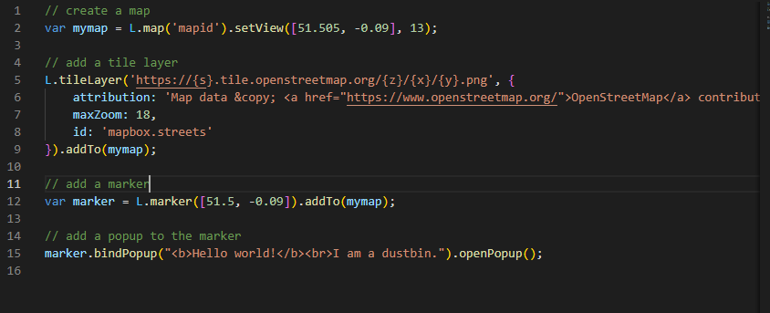

# **6.5 Summary**

The implementation of a location-based garbage management system web application involves the development of a user-friendly online platform that leverages GPS technology, analytics, and automation to improve the efficiency and effectiveness of garbage collection. All these features have been implemented on the system with some additional features.

# 

# **CHAPTER SEVEN**

**FINDINGS, CONCLUSION AND RECOMMENDATIONS**

# **7.0 Findings**

Several researchers have explored the development of location-based garbage management systems, and most of the efforts have been focused on mobile-based systems. The use of mobile devices and location-based services provides real-time tracking of garbage bins, enabling efficient waste collection and management. The web-based systems can be accessed by both users and waste collectors, facilitating the communication and coordination between them.

The literature review also revealed that the location-based garbage management systems have evolved over time, and several functionalities and components have been added to improve the system's performance. For instance, some systems incorporate machine learning algorithms to predict the amount of waste generated in a particular area, facilitating efficient allocation of resources. Other systems use sensors and Internet of Things (IoT) devices to monitor the fill level of garbage bins, enabling timely waste collection.

Moreover, the literature review highlighted the importance of integrating the location based garbage management system with other urban systems, such as transportation and energy management systems. The integration can help optimize the use of resources and improve the overall efficiency of the urban system.

# **7.1 Conclusion**

The literature review has shown that location-based garbage management systems have great potential to improve the efficiency of waste collection and management. Most of the researchers have focused on mobile-based systems, and the use of machine learning algorithms, IoT devices, and sensors can enhance the system's performance. The integration of the system with other urban systems can further optimize the use of resources and improve the overall efficiency of the urban system.

# **7.2 Recommendation/ future work**

Based on the literature review, the following recommendations and future work can be proposed for location-based garbage management systems:

* Integration with Smart City Infrastructure: As mentioned earlier, the integration of location-based garbage management systems with other urban systems such as transportation and energy management systems can optimize the use of resources and improve the overall efficiency of the urban system. Therefore, future work can focus on developing an integrated system that can communicate and share data with other urban systems to achieve a more sustainable and efficient urban environment.
* Machine Learning-based Waste Prediction: Machine learning algorithms can be used to predict the amount of waste generated in a particular area, facilitating efficient allocation of resources. Therefore, future work can explore the development of predictive models that can be trained using historical data and used to forecast future waste generation. The models can be integrated with the location-based garbage management system to facilitate efficient waste collection and management.
* Incentives for Citizen Participation: Citizen participation is critical to the success of any waste management system. Therefore, future work can explore the development of incentives to encourage citizens to participate actively in waste management. For instance, a reward system can be developed that provides incentives to citizens who dispose of their waste properly.
* Real-time Monitoring of the Garbage Truck Fleet: Real-time monitoring of the garbage truck fleet can improve the efficiency of the waste collection process. Therefore, future work can explore the use of GPS-based tracking systems to monitor the location and movement of the garbage trucks in real-time. The data can be used to optimize the route taken by the garbage trucks, reducing the time taken to collect the waste.

* Inclusion of Social Media: Social media can be used to engage citizens in waste management activities. Therefore, future work can explore the development of social media platforms that can be integrated with the location-based garbage management system. The platforms can be used to provide citizens with real-time updates on the waste collection process, and to encourage them to participate actively in waste management activities.

In conclusion, the development of location-based garbage management systems is a promising approach to address the challenges associated with traditional waste management methods. The recommendations and future work proposed above can further improve the efficiency and effectiveness of the system and help achieve a more sustainable and efficient urban environment.

# **REFERENCES**

1. Monika K A, Nikitha Rao, Prapulla S B, “Smart Dustbin an Efficient Garbage Monitoring System,” Shobha International Journal of Scientific & Engineering Research, vol 6, Issue 9, 2015, pp787 789.
2. Parkash, Prabu, " IoT Based Waste Management for Smart City," (An ISO 3297: 2007 Certified Organization), Vol. 4 Issue 2 February 2019.
3. Pranjal Lokhande, M.D.Pawar ," Pawar2International Journal of Engineering and Computer Science," ISSN: 2319 7242, Volume 5 Issue 11 Nov. 2018, Page No. 18800 18805.
4. Ruhin Mary Saji, Drishya Gopakumar , Harish Kumar S, K N Mohammed Sayed,Lakshmi S “A Survey on Smart Garbage Management in Cities using IoT” s5 International Journal of Engineering and Computer Science ISSN: 2319 7242 Volume 5 Issue 11 Nov. 2020, Page No. 18749 18754.
5. Council, Colombo Municipal. "Colombo Municipal Council." Garbage Collection. [Online]. Available: http://colombo.mc.gov.lk/garbagecollection.php/. [Accessed: 04 Jan 2017].
6. S. Lokuliyana , J. A. D. C. A. Jayakody, L. Rupasinghe, and S. Kandawala , "IGOE IoT framework for waste collection optimization," 2017 6th National Conference on Technology and Management (NCTM), Malabe, 2017, pp. 12 16.
7. J. Joshi, J. Reddy, P. Reddy, A. Agarwal, R. Agarwal, A. Bagga, and A. Bhargava, “Cloud computing based smart garbage monitoring system,” 08 2016, pp. 70 75.
8. D. Nirmala, G. Bala, S. Kaviya, and S. Mary, “Smart waste management using internet of things ( iot ),” International Journal of Pure and Applied Mathematics, vol. 119, pp. 203 205, 01 2018.
9. Prof.M.R.Gidde, Prof Dr.V.V.Todkar, Prof K.K.Kokate, Indo Italian conference on green and clean environment march 20-21, MAEER’s MIT college of Engineering, Pune.
10. “Municipal solid waste management in emerging mega cities: A Case Study of Pune City”.
11. Kim Peters, City farmer, Canada’s office of urban agriculture. Community-based waste management for environmental management and income Generation in Low-income (2018).
12. Areas: A case study of Nairobi, Kenya.
13. Wilson, D. C. (2007). Development drivers for waste management. Waste Management & Research the Journal of the International Solid Wastes & Public Cleansing Association Iswa, 25(3), 198-207.
14. Monika K A, Nikitha Rao, Prapulla S B, “Smart Dustbin an Efficient Garbage Monitoring System,” Shobha International Journal of Scientific & Engineering Research, vol 6, Issue 9, 2015, pp787 789.
15. Parkash, Prabu, " IoT Based Waste Management for Smart City," (An ISO 3297: 2007 Certified Organization), Vol. 4 Issue 2 February 2019.
16. Pranjal Lokhande, M.D.Pawar ," Pawar2International Journal of Engineering and Computer Science," ISSN: 2319 7242, Volume 5 Issue 11 Nov. 2018, Page No. 18800 18805.
17. Ruhin Mary Saji, Drishya Gopakumar , Harish Kumar S, K N Mohammed Sayed,Lakshmi S “A Survey on Smart Garbage Management in Cities using IoT” s5 International Journal of Engineering and Computer Science ISSN: 2319 7242 Volume 5 Issue 11 Nov. 2020, Page No. 18749 18754.
18. Council, Colombo Municipal. "Colombo Municipal Council." Garbage Collection. [Online]. Available: http://colombo.mc.gov.lk/garbagecollection.php/. [Accessed: 04 Jan 2017].
19. S. Lokuliyana , J. A. D. C. A. Jayakody, L. Rupasinghe, and S. Kandawala , "IGOE IoT framework for waste collection optimization," 2017 6th National Conference on Technology and Management (NCTM), Malabe, 2017, pp. 12 16.
20. J. Joshi, J. Reddy, P. Reddy, A. Agarwal, R. Agarwal, A. Bagga, and A. Bhargava, “Cloud computing based smart garbage monitoring system,” 08 2016, pp. 70 75.
21. D. Nirmala, G. Bala, S. Kaviya, and S. Mary, “Smart waste management using internet of things ( iot ),” International Journal of Pure and Applied Mathematics, vol. 119, pp. 203 205, 01 2018.
22. Prof.M.R.Gidde, Prof Dr.V.V.Todkar, Prof K.K.Kokate, Indo Italian conference on green and clean environment march 20-21, MAEER’s MIT college of Engineering, Pune.
23. D. Nirmala, G. Bala, S. Kaviya, and S. Mary, “Smart waste management using internet of things ( iot ),” International Journal of Pure and Applied Mathematics, vol. 119, pp. 203 205, 01 2018.
24. Wilson, D. C. (2007). Development drivers for waste management. Waste Management & Research the Journal of the International Solid Wastes & Public Cleansing Association Iswa, 25(3), 198-207.
25. Ruhin Mary Saji, Drishya Gopakumar , Harish Kumar S, K N Mohammed Sayed,Lakshmi S “A Survey on Smart Garbage Management in Cities using IoT” s5 International Journal of Engineering and Computer Science ISSN: 2319 7242 Volume 5 Issue 11 Nov. 2020, Page No. 18749 18754.
26. Council, Colombo Municipal. "Colombo Municipal Council." Garbage Collection. [Online]. Available:http://colombo.mc.gov.lk/garbagecollection.php/. [Accessed: 04 Jan 2017].
27. Collection optimization," 2017 6th National Conference on Technology and Management (NCTM), Malabe,2017, pp. 12 16.
28. J. Joshi, J. Reddy, P. Reddy, A. Agarwal, R. Agarwal, A. Bagga, and A. Bhargava, “Cloud computing based smart garbage monitoring system,” 08 2016, pp. 70 75.

# **Appendices**

Appendix A**:**

**Frequently Asked Questions**

**Q1: What is a location-based garbage management system? A:**

A location-based garbage management system is a system that uses geolocation technology to manage the collection and disposal of garbage. It allows users to report garbage locations and track garbage collection routes.

**Q2: How does the system work? A:**

The system works by using geolocation technology to track the location of garbage bins and trucks. Users can report garbage locations through the system's web application, and the system will notify the nearest garbage truck to collect the garbage. The system also allows users to track the garbage truck's route and estimated arrival time.

**Q3: Is the system available in my area? A:**

The availability of the system depends on your location and the local government's policies. Please check with your local government or waste management authority for more information.

**Q4: How do I report a garbage location? A:**

You can report a garbage location through the system's mobile application. Simply select the "Report Garbage" option, and the application will prompt you to enter the garbage location and type.

**Q5: How do I track the garbage truck's route? A:**

You can track the garbage truck's route through the system's mobile application. Simply select the "Track Truck" option, and the application will display the truck's current location and estimated arrival time.

**Glossary of Terms The following terms are used throughout the user manual:**

**Location-based garbage management system**: Refers to the specific system being used. **Geolocation technology**: Refers to technology that uses GPS/google maps or other location tracking technologies to determine the location of a device or object.

* Garbage bin: Refers to a container for storing garbage.
* Garbage truck: Refers to a vehicle used for collecting and transporting garbage.
* Web application: Refers to a software application designed for use on mobile devices, such as smartphones or tablets.

# Appendix B

# **Questionnaire**

Thank you for taking the time to provide your input on the Location-Based Garbage Management System. Your responses will help us better understand the potential impact of this system**.**

NAME: _______________________________________________________

DEPARTMENT:________________________________________________

DATE:**_________________________________________________________**

**How effective do you think a Location-Based Garbage Management System would be in managing garbage collection in your area?**

A. VERY EFFECTIVE

B. SOMEWHAT EFFECTIVE

C. NOT EFFECTIVE

**Do you believe that incorporating location-based technology would significantly improve the efficiency of garbage collection?**

A. YES

B. NO

**Do you think that the current manual garbage collection system in your area needs to be upgraded to a location-based system?**

A. YES

B. NO

**Do you think that lack of internet connectivity or technological infrastructure may hinder the implementation of a Location-Based Garbage Management System?**

A. YES

B. NO

**How important do you think it is to have a smart, location-based system for managing garbage collection?**

A. VERY IMPORTANT

B. IMPORTANT

C. SOMEWHAT IMPORTANT

D. NOT IMPORTANT

**What potential benefits do you see in implementing a Location-Based Garbage Management System?**

A. Optimal and efficient route planning for garbage collection trucks

B. Reduced fuel consumption and cost savings

C. Improved scheduling and resource allocation

D. Enhanced monitoring and reporting of garbage collection activities

E. Better responsiveness to changing garbage collection needs in different locations

**What challenges do you anticipate in implementing a Location-Based Garbage Management System?**

A. Resistance to change from employees or stakeholders

B. High initial setup and maintenance costs

C. Ensuring accurate and up-to-date location data

D. Training employees to use the system effectively

E. Addressing potential privacy concerns related to location data

**How confident are you that the implementation of a Location-Based Garbage Management System would be successful?**

A. VERY CONFIDENT

B. CONFIDENT

C. UNSURE

D. NOT CONFIDENT

**What suggestions or feedback do you have for improving the implementation of a Location-Based Garbage Management System in your area?**

Thank you for your valuable input. Your responses will be instrumental in shaping the development and implementation of the Location-Based Garbage Management System.

## APPENDIX C**: RESEARCH SCHEDULE**

The research schedule was presented in form of a Gantt chart. The Gantt chart shows all the tasks that were carried out in the course of carrying the project.

|  |  |  |  |  |  |  |  |  |  |  |  |  |
| --- | --- | --- | --- | --- | --- | --- | --- | --- | --- | --- | --- | --- |
| Activities | Week 1 | Week 2 | Week 3 | Week 4 | Week 5 | Week 6 | Week 7 | Week 7 | Week 8 | Week 9 | Week 10 | Week 11 |
| **Title project presentation** |  |  |  |  |  |  |  |  |  |  |  |  |
| **Reading the whole of chapter one** |  |  |  |  |  |  |  |  |  |  |  |  |
| **Writing chapter one** |  |  |  |  |  |  |  |  |  |  |  |  |
| **Going for project consultation** |  |  |  |  |  |  |  |  |  |  |  |  |
| **Reading on Literature Review** |  |  |  |  |  |  |  |  |  |  |  |  |
| **Researching from different journals** |  |  |  |  |  |  |  |  |  |  |  |  |
| **Writing literature review** |  |  |  |  |  |  |  |  |  |  |  |  |
| **Determining data collection and development tools to use** |  |  |  |  |  |  |  |  |  |  |  |  |
| **Writing chapter three** |  |  |  |  |  |  |  |  |  |  |  |  |
| **Writing Appendices** |  |  |  |  |  |  |  |  |  |  |  |  |
| **Corrections on the whole document** |  |  |  |  |  |  |  |  |  |  |  |  |
| **Writing and presenting the whole document** |  |  |  |  |  |  |  |  |  |  |  |  |

## **APPENDIX D: BUDGET**

|  |  |  |  |  |
| --- | --- | --- | --- | --- |
| **ITEM** | **DESCRIPTION** | **UNIT COSTS**  **(KSH)** | **QUANTITY** | **TOTAL COST** |
| Documentation and Literature |  |  |  |  |
| Laptop |  | 35000 | 1 | 35000 |
| Travel | Bus fare | 40 | 12 | 480 |
| Internet Services | Wi-Fi services | 500 | 3 | 1500 |
| Printing, Scanning, Photocopying and Binding | Final print and progressions | 150 | 6 | 900 |
| Total |  |  |  | 37880 |

**APPENDIX E:**

**FEASIBILITY REPORT FOR LOCATION-BASED GARBAGE MANAGEMENT SYSTEM AT MAKUTANO APARTMENTS.**

**Purpose:**

The purpose of this feasibility report is to assess the viability of implementing a location-based garbage management system at Makutano Apartments. The report will investigate two possible alternative solutions to address the garbage management issue.

**ALTERNATIVE SOLUTIONS:**

Web Application-Based System: This solution involves developing a web application that allows residents of Makutano Apartments to report garbage-related issues such as overflowing bins, missed garbage pickups, and illegal dumping. The application will use location-based technology to pinpoint the exact location of the issue, making it easier for the management to address the problems promptly.

**Economic Feasibility:**

Cost of purchasing and installing the sensors on the garbage bins.  
Ongoing maintenance and updates costs for the sensor system.  
Possible costs for training and educating the management on how to use the sensor system.

**Operational Feasibility:**

Integration with existing garbage collection and disposal processes.  
Timely notifications to the management about fill levels of bins for efficient waste collection.  
Reduction in overflowing bins and missed pickups.

**Technical Feasibility:**

Availability of suitable sensor technology for garbage bins.  
Reliable connectivity for transmitting sensor data to a central system.  
Compatibility with existing garbage management infrastructure.

**Recommendation:**

Based on the feasibility analysis, both the mobile application-based system and the sensor-based system are technically feasible for implementation. However, the mobile application-based system is more economically feasible as it involves lower initial costs and ongoing maintenance costs compared to the sensor-based system. The mobile application-based system also offers the advantage of engaging residents in the garbage management process and empowering them to report issues in real-time, leading to prompt resolutions**.**Therefore, it is recommended to proceed with the implementation of a location-based garbage management system at Makutano Apartments through the development of a web application-based system. This solution has the potential to improve the efficiency of garbage management processes, reduce the occurrence of overflowing bins, and enhance overall resident satisfaction.

# **USER MANUAL: LOCATION-BASED GARBAGE MANAGEMENT SYSTEM**

**Introduction**

The Garbage Management System is a web-based application designed to streamline the management of waste collection and complaints. The system has three main modules: Admin, Driver, and User. The Admin module is for system administrators to manage the overall system, the Driver module is for drivers to view and manage assigned tasks, and the User module is for users to lodge complaints and view complaint status.

**System Access**

To access the Waste Management System, open a web browser and enter the system URL in the address bar. The system will load the login page. Users can log in to the system using their respective credentials: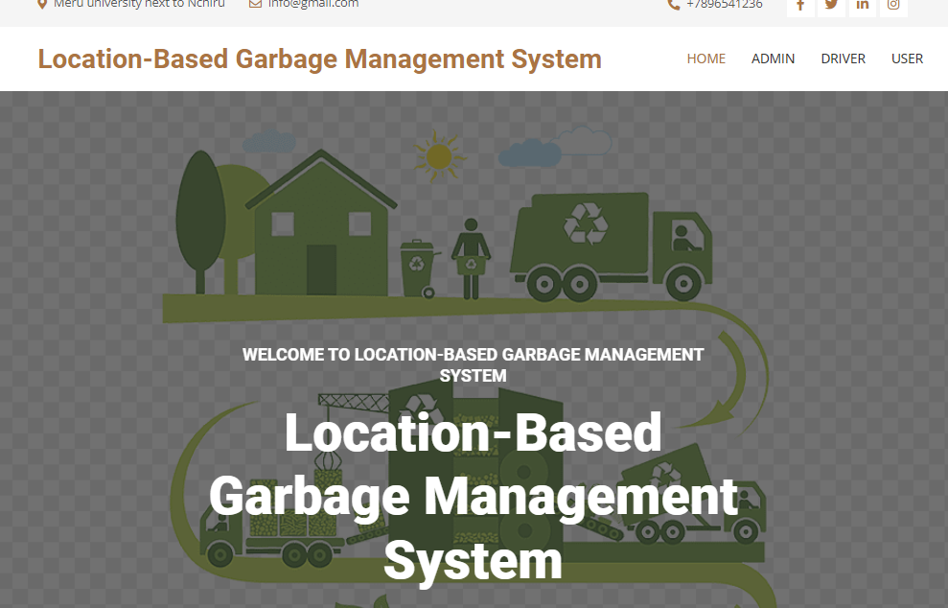

Admin: Enter the username and password provided by the system administrator.

Driver: Enter the username and password provided by the admin.

User: Register for an account on the system or use the login credentials provided by the admin.

Dashboard

Upon successful login, users will be directed to the dashboard of their respective modules.

Admin Dashboard: The Admin dashboard provides a summary of new lodged complaints, assigned lodged complaints, rejected lodged complaints, completed lodged complaints, total drivers, total bin cleaning in progress, and total bins cleaned.

Driver Dashboard: The Driver dashboard provides a summary of assigned complaints, complaints in progress, completed complaints, assigned garbage bins, bin cleaning in progress, and total bins cleaned by the driver.

User Dashboard: The User dashboard displays welcome message and provides options to lodge a complaint or view complaint history.

Functionality by Module

**Admin Module**

Create Bin: In this section, the admin can manage bins by adding, updating, and deleting bins. The admin can provide the bin name, location, and status.

Manage Drivers: In this section, the admin can manage drivers by adding, updating, and deleting drivers. The admin can provide driver details such as username, password, first name, last name, email, and phone number.

Manage Pages: In this section, the admin can manage About Us and Contact Us pages by updating the content.

Complain: In this section, the admin can view complaints received from users and assign them to drivers for resolution.

Driver Complain Response: In this section, the admin can view the status of complaints marked as resolved by drivers.

Driver Bin Response: In this section, the admin can view the status of garbage bins marked as cleaned by drivers.

Search: In this section, the admin can search for assigned garbage bins by bin ID and view complaint details by complaint number.

Reports: In this section, the admin can generate reports between dates for bin cleaning, driver-wise bin cleaning, lodged complaints, and driver-wise lodged complaints.

Reg Users: In this section, the admin can view the details of registered users.

Profile Management: The admin can update their profile information, change the password, and recover the password.

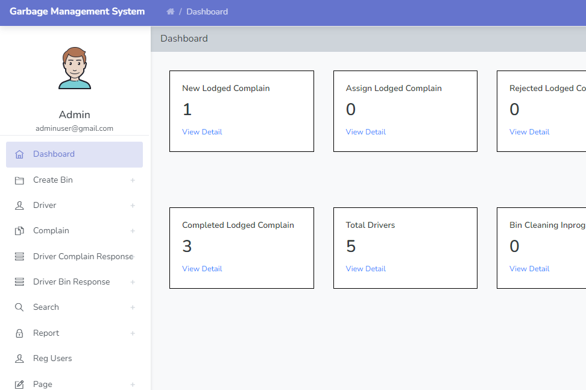

**Driver Module**

Assign Complaint: In this section, the driver can view assigned complaints from the admin and update the status of the work as in progress or completed.

Assign Garbage Bin: In this section, the driver can view assigned garbage bins from the admin and update the status of the work as in progress or completed.

Search: In this section, the driver can search for assigned garbage bins by bin ID and view complaint details by complaint number.

Reports: In this section, the driver can view reports for collected bins and lodged complaints between two dates.

Profile Management: The driver can update their profile information, change the password, and recover the password.

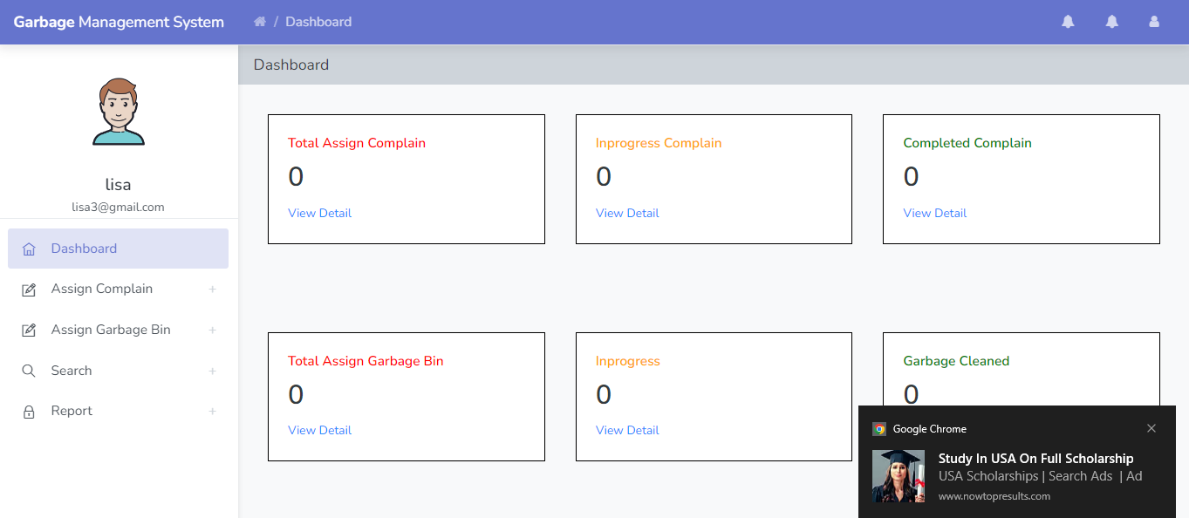

**User Module**

Lodge Complaint: In this section, the user can lodge a complain